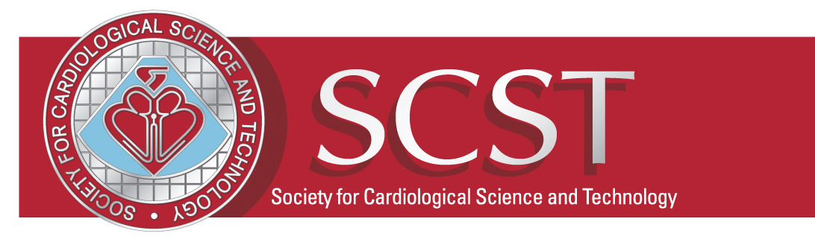

SCST Annual National Update Meeting 2019
On behalf of SCST, I would like to invite you as sponsors to our annual National Update Meeting in Austin Court, Birmingham which will be held on Friday 22nd November 2019.

SCST is the professional body for cardiac physiologists and cardiac healthcare scientists in the UK. Over 100 clinical staff and departmental managers from around the country and Northern Ireland attended the National Update meeting 2018.

Please find attached the exhibition application form for 2019 Prices start from £250 for a bag insert.

If you would like to discuss your stand requirements for SCST National Update Meeting 2019 then please either email or contact me on admin@scst.org.uk

Alternatively, please complete the attached Stand Booking Form and return this to me via email.

We very much hope you will join us in what will be an interactive event in a well-established national meeting.

I look forward to hearing from you.

Kind regards

EXHIBITION STAND BOOKING FORM
SCST National Update Meeting 2019
Friday 22nd November, Austin Court, Birmingham
This event is now the established annual meeting for all senior staff working in cardiac healthcare science. It provides your company with a prime opportunity to network and showcase your company to Cardiac Scientists, Principal Cardiac Physiologists and department managers.
This year we are extending the sessions to all grades dividing the teaching sessions to include ECG interpretation and practical workshops.
Company:
Address:

Contact: | Position:
Telephone:
Email address:

Delegate bag insert - £250
To include:
- Opportunity to include product information, educational material or leaflets in the delegate packs

Exhibition stand - £2000
To include:
- Opportunity to include product information, educational material or leaflets in the delegate packs
- Stand – 3mx1m open table top stand located within the refreshment room all day
- Refreshments and lunch for two people
(VAT is not applicable to the above prices.)
Names of attendees:
Specific requirements for stand (i.e. number of electric sockets required)

If successful with this request, payments can be made payable to:
Payments made to: SCST- The Society for Cardiology Science and Technology
Sort:54-21-23
Ac: 08234507
IBAN: GB39 NWBK 5421 2308 2345 07
BIC/SWIFT: NWBK GB 21

