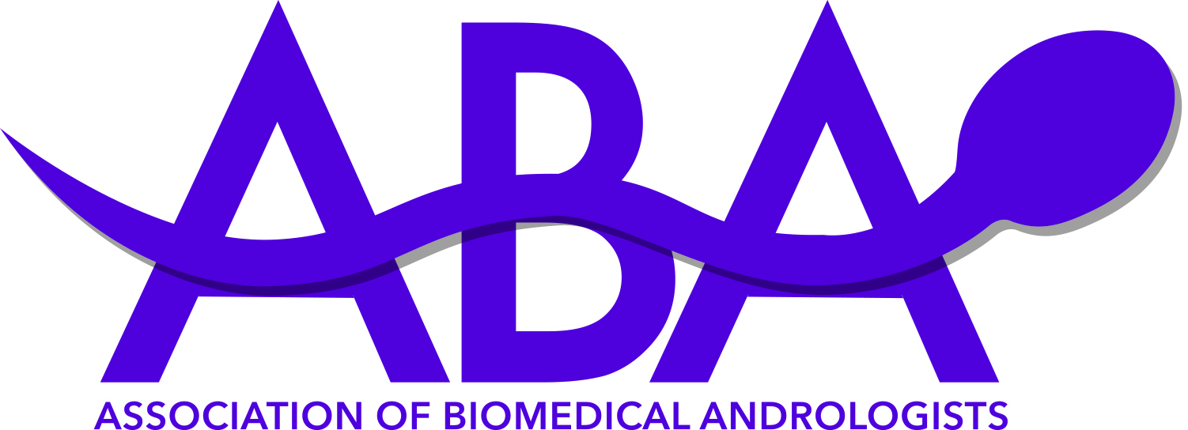

REGISTRATION FORM

Best Practice Day and Annual General Meeting,

23rd and 24th May 2018
Please reserve a place for me at the ABA Best Practice Day and Annual General Meeting at the Leeds Marriott Hotel, 4 Trevelyan Square, Boar Lane, Leeds, LS1 6ET on 23rd and 24th May 2018.

Closing date for meeting applications is: 11th May 2018
PLEASE NOTE: A PO is required if you wish to attend the meal as we cannot book this without full payment.
Name |  | I am a member of | ABA / ACE / BAS / IBMS
Address
Postcode |  | Contact telephone number

Email

Please tick the appropriate box below. All rates are based on the date the applications are received. Any forms with the incorrect box ticked may be rejected.
 | ABA  Member Rate |  | ACE/BAS/IBMS  Member Rate |  | Non-Member  Rate
DAY 1: Best Practice – Donor Sperm Day |  | £80 |  | £110 |  | £125
DAY 2: ABA Annual General Meeting 2018 |  | £80 |  | £110 |  | £125
DAY 1 & 2 Inclusive |  | £140 |  | £190 |  | £225
Evening Meal on 23rd May 2018 (AM Kitchen and Bar) |  | £20 |  | £20 |  | £20
Please tick box if a receipt is required
PLEASE INDICATE ANY DIETARY REQUIREMENTS:

PAYMENTS (select from the following options):
Cheque/PO. Please enclose a cheque made payable to “The Association of Biomedical Andrologists” with your form.
If payment is being made by your employer or any other organisation, please attach either the cheque or a Purchase Order Number. Full payment must be received in advance to secure a place at the meeting. No payment will be accepted on the day. Places are limited and fill up quickly. Book early to avoid disappointment!

PayPal: Use our online booking on the ABA website events page https://www.aba.uk.net/events/ or directly to treasurer@aba.uk.net – please state the names of the delegates if paying for more than one person.
Exhibiting companies may request contact details for delegates to send marketing information. If you do not wish your details to be passed to such requesting companies please tick the box. Please note, you are not permitted to discuss commercial business unless registered as a trade delegate. Failure to adhere to this rule may result in ejection from the meeting. Photographs for publication and social media may be taken at any time throughout the meeting. Please advise a member of the ABA Executive Committee on the day if you object to your photograph being published.
Please send completed forms to: The ABA AGM, ^{c}/_{o} The Andrology Laboratory, Level 4, The Jessop Wing, Tree Root Walk, Sheffield, S10 2SF.

Contact registration@aba.uk.net if you do not receive your confirmation within 10 working days.
Cancellation policy: Cancellation > 4 weeks in advance: 50% of the total cost charged. Non-attendance or cancellation within 4 weeks: 100% of total cost charged. A £50 administration fee will be charged for all cancellations. Cancellation must be in writing.

